Time Travel

Is it possible?

By
Amit Chetry (B.Tech ADE 1st year)
Kaustavdeep Goswami
(B.Tech CSE-MFT 1st year)

Time is the measurement of change. For us, time has no dimension, it flows in only one direction i.e. forward. We can’t bend time but we can travel faster than it. According to Wikipedia, time is nothing but the indefinite continued progress of existence and events that occur in apparently irreversible succession from the past through the present to the future.
As per Neil deGrasse Tyson, a famous astrophysicist, time is defined to make motion look simpler, because we can’t define motion without some reference to time. Time makes all of us a prisoner of present, forever transitioning from our own past into an unknown future. We can move in any coordinate like up-down, left-right, forward-backward but stuck in time, we can’t move backward-forward in time arbitrarily.
Time is flexible and relative and according to Albert Einstein, “the dividing line between past, present and future is an illusion. ”So reality is ultimately timeless. This sounds pretty bizarre from the view of classical physics but from the view of consciousness theory and spirituality, it fits in perfectly.

- When did time start?
From the very day when big bang occurred, time was created, time is actually the measurement of expansion of universe. It is the measurement of disorder of things.

- Time isn’t absolute, but relative:
Why we being the people living on earth don’t have same time everywhere? Why it’s when 12 AM on IST, it’s 12 PM in USA? Why is it?
It is due to the relative nature of time. Time depends on the speed of object. If we move at a speed near the speed of light we will experience time dilation and hence time will run slow for us.
Time also depends on the gravitational field, stronger the gravitational field, slower the time will run and vice versa.

- Time dilation:
According to Einstein’s theory of relativity, when an object travels near the speed of light, it experiences a time which is slower with respect to earth.

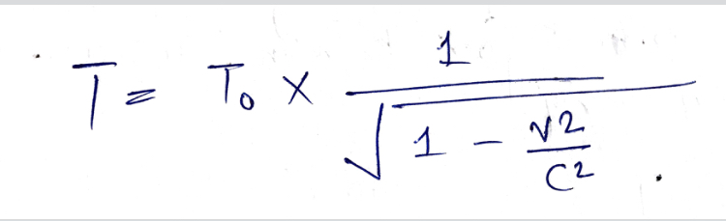

This mathematical equation is the verification of time dilation.
Here, T - Time with respect to earth
To - Time with respect to the object moving with the speed of light.
V - Speed of object
C - Speed of light

For example, if an object travels at speed of 0.8c for 10 min, what will be time on earth?

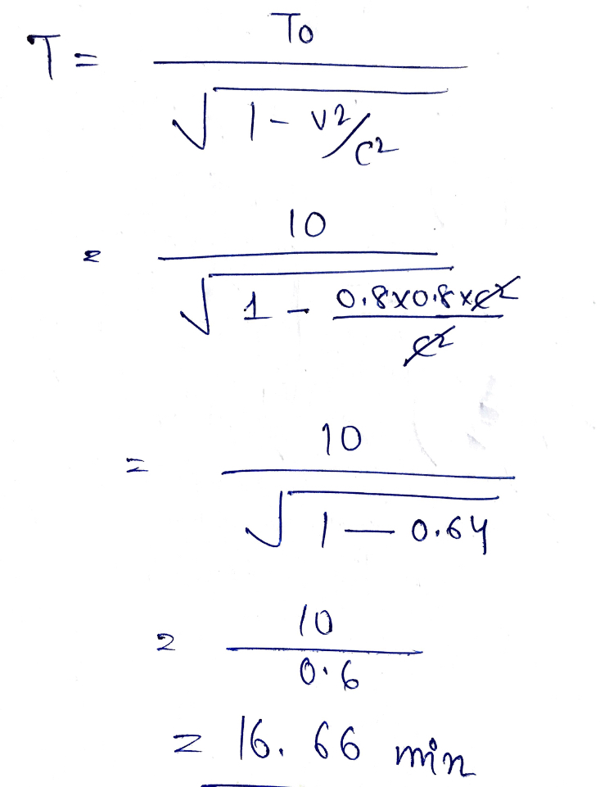
This example says that when the object experiences 10 min, the earth undergoes 16.66 min and hence we can conclude that time is different under different speed.

- How gravitational field affects time?
Time is different for different gravitational field, like even on earth, time moves faster in the places which are away from the center of the earth but in the places which are near the center of the earth, time runs relatively slower.
The main reason for this phenomenon is that the strength of gravitational field of earth gradually decreases away from the center.
Same happens on the space. For masses having more gravitational field, their time is slower with respect to earth (given, G.F. of that mass> G.F. of earth).
For example, 1 hour near blackhole is equal to 10 years on earth. Because gravitational field near blackhole is the maximum gravitational field ever existed (even light can’t escape it).
Einstein has expressed gravitational time dilation in the form of the following equation-
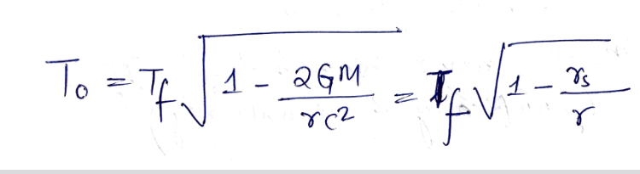
Where,
To - proper time
Tf - coordinate time
G - gravitational constant
M - mass of the object creating the gravitational field
r - radial coordinate of the observer
C - speed of light
rs - Schwarzschild radius of M

For example, twin Z is approaching a black hole to observe the same (theoretically he has not entered the orbit, neither moving but getting close to a blackhole to get affected by the gravitational field of it and the black hole is also not moving in space or rotating) and twin X is staying on the mothership that isn’t moving or getting affected by the gravity. We want to know the time dilation between the two twins due to gravitational field of the black hole.

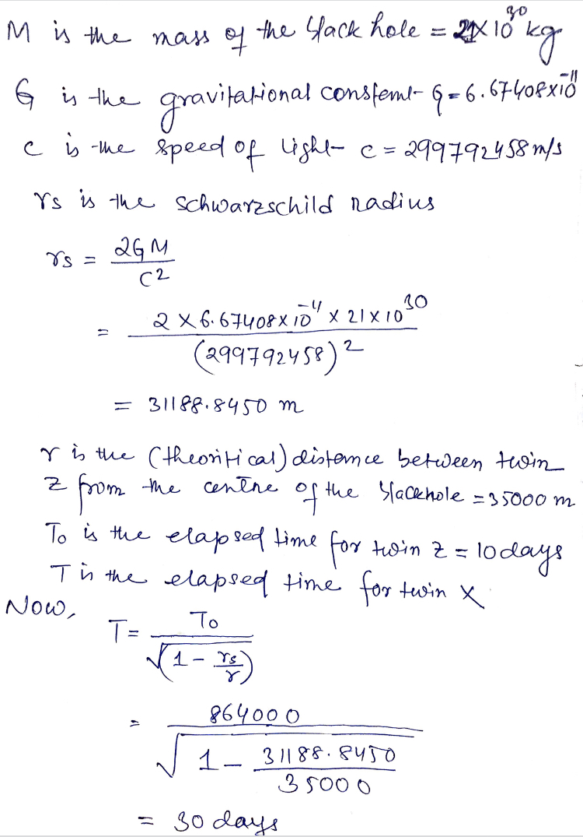
When twin Z comes back on mothership, twin X is 20 days older than Z.
From this example, we can conclude that time is different for different gravitational field.

- Can we travel through time? If yes then how?

The immense twentieth century scientist Albert Einstein built up a hypothesis called Special Relativity. The thoughts of Special Relativity are difficult to envision since they aren't about what we involve in regular day to day existence, however researchers have affirmed them. This hypothesis says that space and time are truly parts of a similar thing—space-time. There's a speed breaking point of 300,000 kilometers for every second (or 186,000 miles for every second) to anything that moves through space-time, and light dependably ventures to every part of it as far as possible through empty space.
Special theory of relativity likewise says that an astounding thing happens when you travel through space-time, particularly when your speed with respect to different items is near the speed of light. Time goes slower for you than for the general population you left. You won't see this impact until the point that you come back to those stationary individuals.
Let's assume you were 15 years of age when you exited Earth in a rocket going at around 99.5% of the speed of light (which is considerably quicker than we can accomplish now) and commended just five birthday celebrations amid your space voyage. When you return home at 20 years old, you would notice that every one of your cohorts were 65 years of age, resigned, and making the most of their grandchildren! Since time passed all the more gradually for you, you will have encountered just five years of life, while your cohorts will have encountered an entire 50 years.
In this way, if your trip started in 2003, it would have taken you just 5 years to travel to the year 2053, while it would take your friends who were on earth 50 years. This implies you have been time traveling. This is a method for setting off to the future at a rate speedier than 1 hour for each hour.
Time travel of a sort likewise happens for objects in gravitational fields. Einstein had another amazing hypothesis called General Relativity, which predicts that time passes all the more gradually for objects in gravitational fields (like here on Earth) than for objects a long way from such fields. So, there are many types of space and time bends near black holes, where the gravity can be very intense.
In the previous couple of years, a few researchers have utilized those bends in space-time to consider conceivable ways time machines could work. Some like "worm holes," which might be shortcuts through space-time. This and different thoughts are wonderfully interesting, but we don't know now whether they are feasible for real objects. Still the thoughts depend on good, solid science. In all time travel theories permitted by real science, it is extremely unlikely a voyager can go back in time.
We can say that time travel into the future is possible but we would need to develop very advanced and high speed space craft. We could travel 10,000 years into the future and age just 1 year during the journey. However, such a trip would consume an extraordinary amount of energy. Time travel to the past is more difficult. We don’t understand the science as well.
As a matter of fact, researchers and engineers who plan and operate some space missions must account for the time distortions that occur because of both general and special relativity. These effects are far so small that it could not matter in most human terms. However, very tiny fraction of a second do matter for the precise work necessary to operate a space craft throughout the solar system.

